**BIOFILMS LAB- Luke Peters & Peng Wang**

**23/03/2021**

**12:00**

Downloaded GRO and ran the ABFDFM.gro:

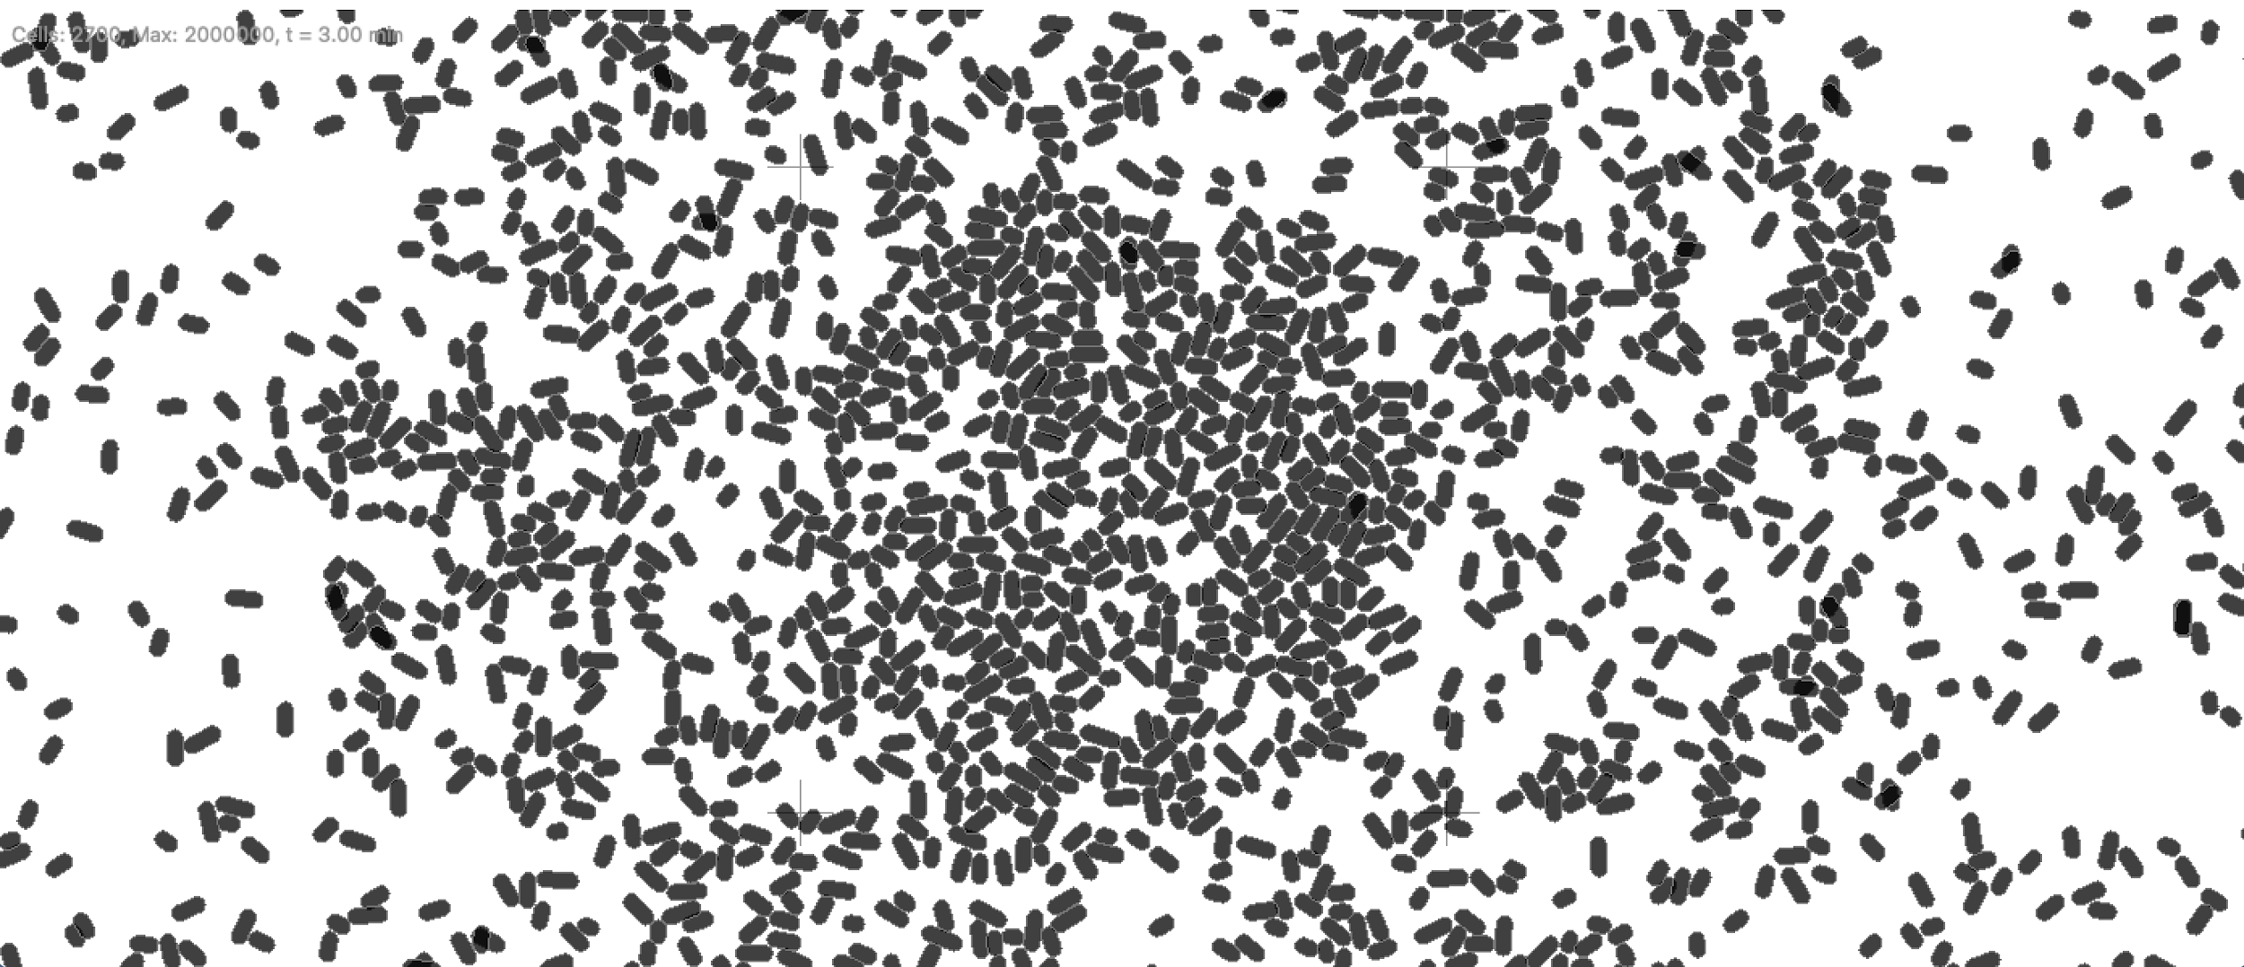

By increasing the timestep of the simulation from 0.1 to 5 we viewed the simulation after 70 minutes of run time we saw the following:

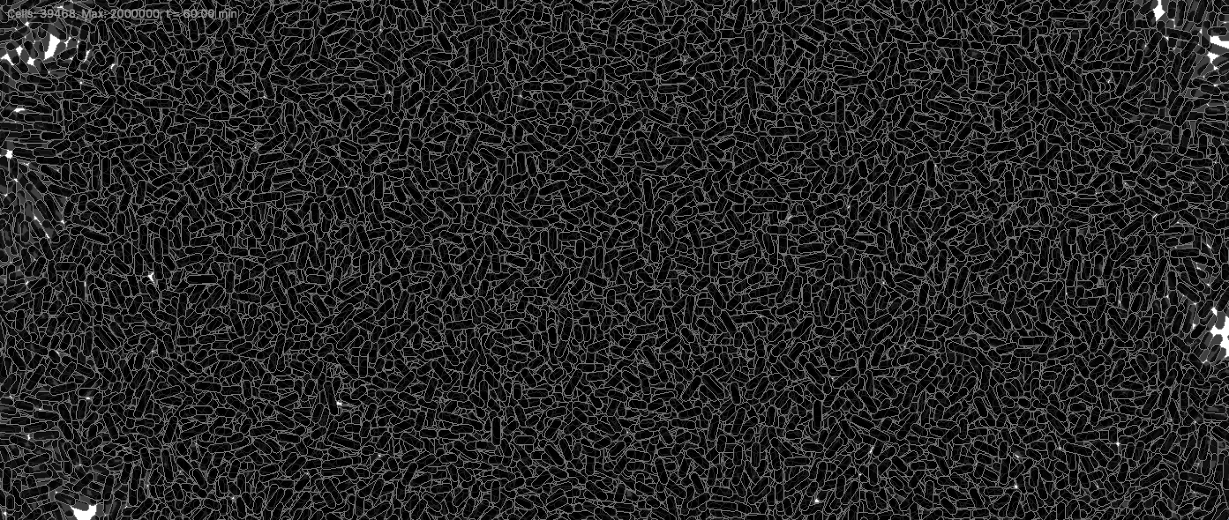

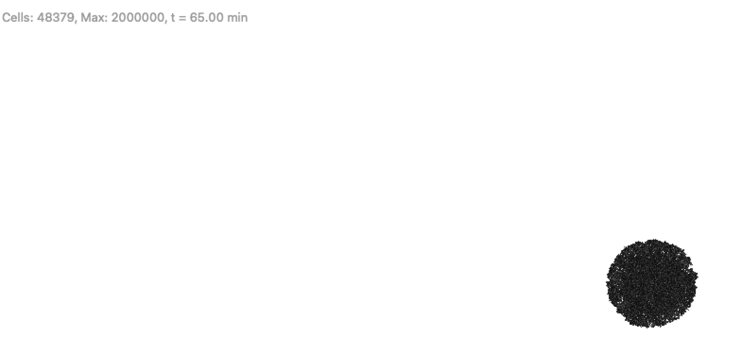

The growth of the cell was a lot more rapid at a time step of 5

**14:59**

We had not yet seen any potassium released by cells, we ran the simulation for longer, and after reaching threshold potassium concentration the bacteria released potassium:

At 228.8 minutes,

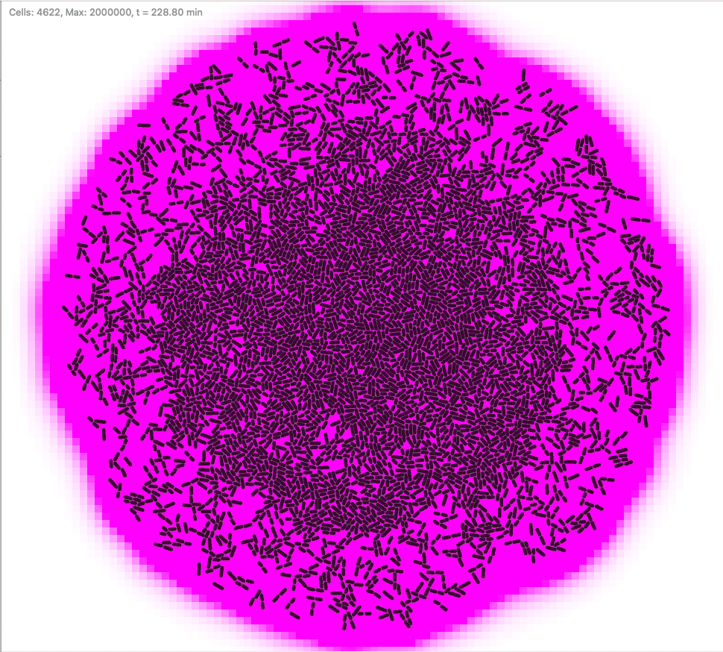

By selecting only one cell and analysing the single_dump data and get_signal(K1) data, we saw clearly that at the time St and st2 were activated (0 to 1) and ref 1 and ref 2 were deactivated (1 to 0). At the corresponding time in the get_signal(K1) data the potassium concentration in the area of the selected cell increased dramatically.

We decided to output the single_dump data and get_signal(K1) data to the same csv file as this aids in data analysis. This was done by editing the code to:

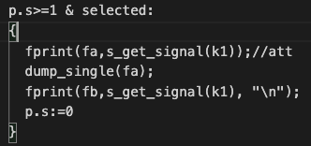

Our final CSV, outputs will look as follows,

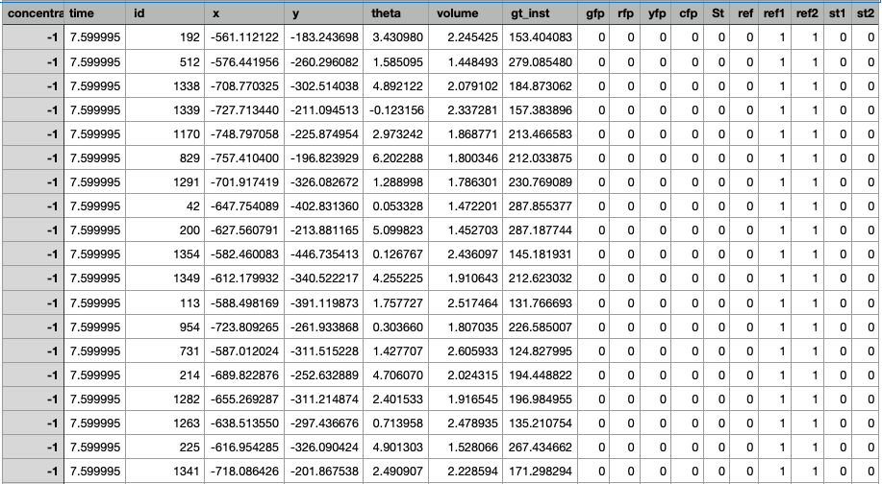

**MODULE PARAMETERS**

dt: timestep of simulation[minutes]

population-max: limit on number of bacteria

t: initial time

i: ????

ecoli_growth_rate: rate of cell growth

nocell: no. of cells at the start

phi: 2*pi/nocell

**SET ENVIRONMENTAL SIGNALS**

signals: 0.0=off, 1.0=on

signals_draw: 0.0=off, 1.0=on [if off then relased potassium not drawn in pink]

grid:( "continuous", "gro_original", 20,20,1);

k1 := s_signal([kdiff := 0.4, kdeg := 0.07]);

Signal identified by K1

Parameters of K1:

kdiff: diffusion coefficient

kdeg: degradation coefficient

**GENETIC ENTITIES**

**OPERONS**

(Not relevant right now)

**ACTIONS**

**s_get_QS: Senses a signal and if a comparison is successful then a genetic element protein is activated, otherwise deactivated**

1. If potassium>threshold(0.8) & St is absent: Activates gene st1 ”stress”
2. If potassium>threshold(0.9): Transcription factor deactivated
3. If potassium<threshold(1.1) & St is absent: Activates ref1 “refractory”
4. If potassium<threshold(1.0): Activates ref 2 “refractory”

**s_emit_signal: Emits a signal with a given concentration:**

1. If ST is present, emit potassium at concentration(0.3) under the entire area of the bacterium

**Saving data**

Route 1: Location of CSV files

(Cells must be manually selected to save data. )

If a cell is selected:

fa=allcells1.csv dump_single

fb=allcells11.csv s_get_signal(k1) -Concentration present in the selected cell

We will a single .csv file which includes the collated dump_single and s_get_signal data. Eg: titles: concentration, id, x,y etc……..

**Saving images**

Route 2: Location of images

t2 > 3 : (every 3 minutes)

(save an image as):

snapshot ( tosring(t1) <> tostring(n) <> route2 <> ".tif" ),

n := n + 1,

t2 := 0 (resets to zero to maintain loop, every 3)

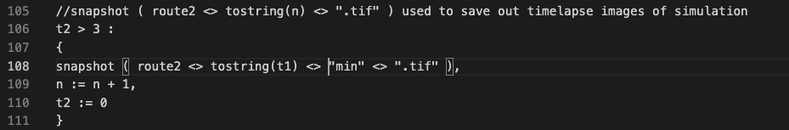

We then plotted graphs of k concentration while both time and distance vary. We used the original parameters in our .gro simulation:

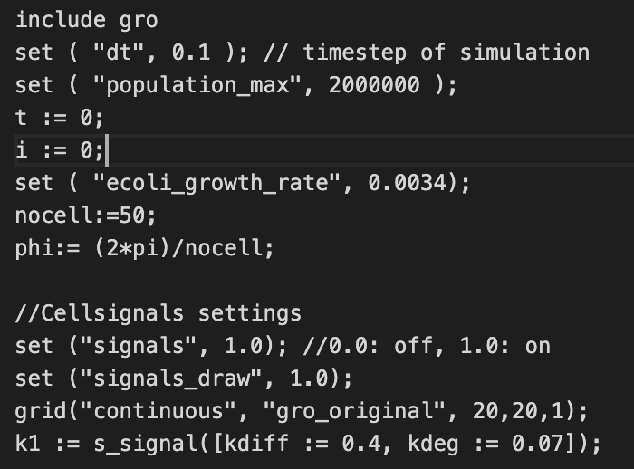

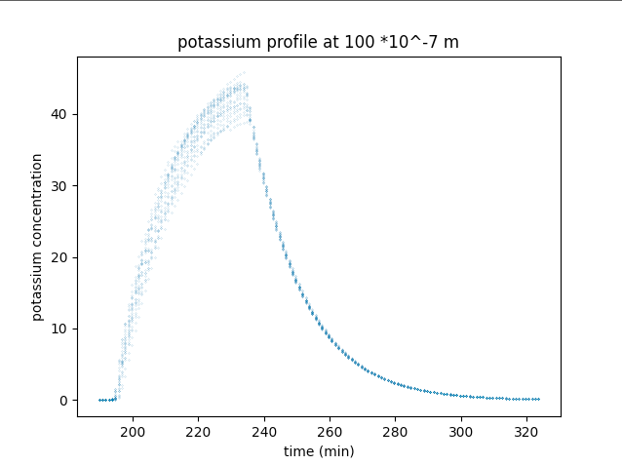

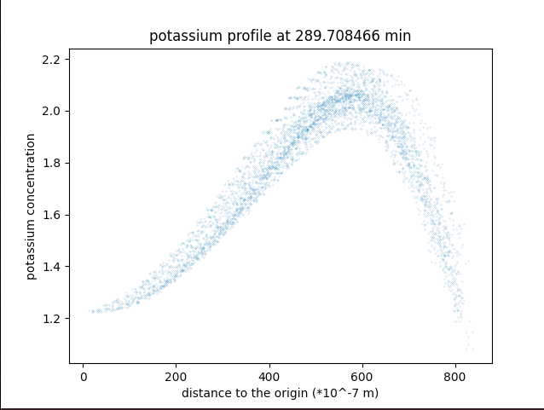

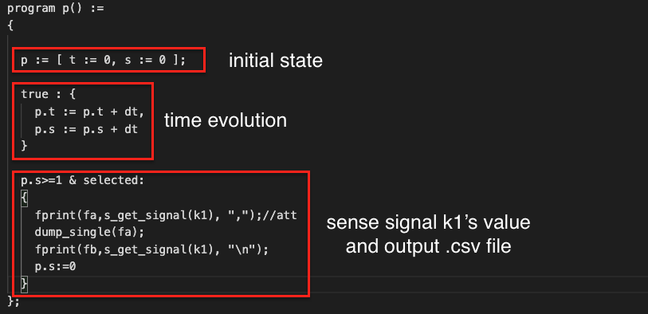

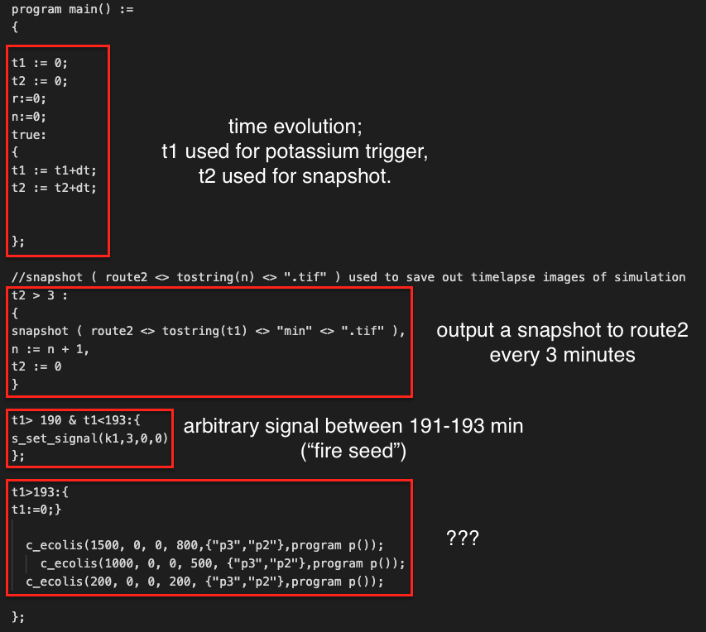

The lines of code marked “???”, indicate that when t1 increases above 193 and the initial “potassium trigger” has occurred t1 is then set to zero again. Does this mean that at a global time of 380 there will be another trigger in the centre? If so why? We ran a simulation：

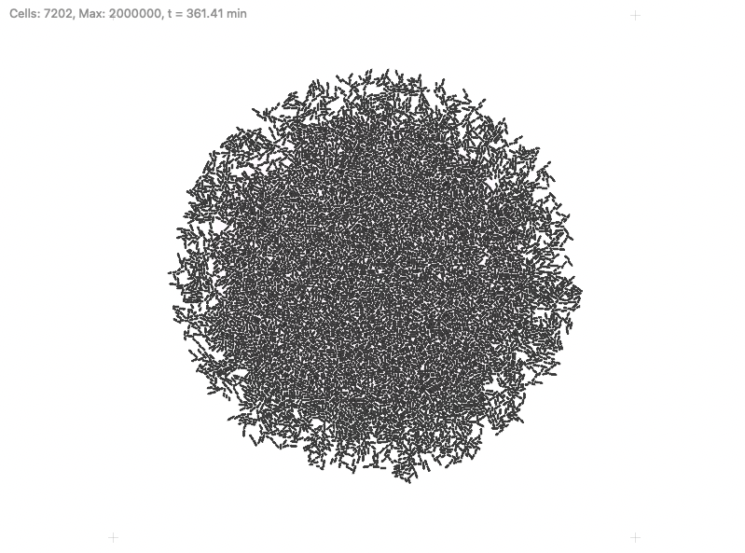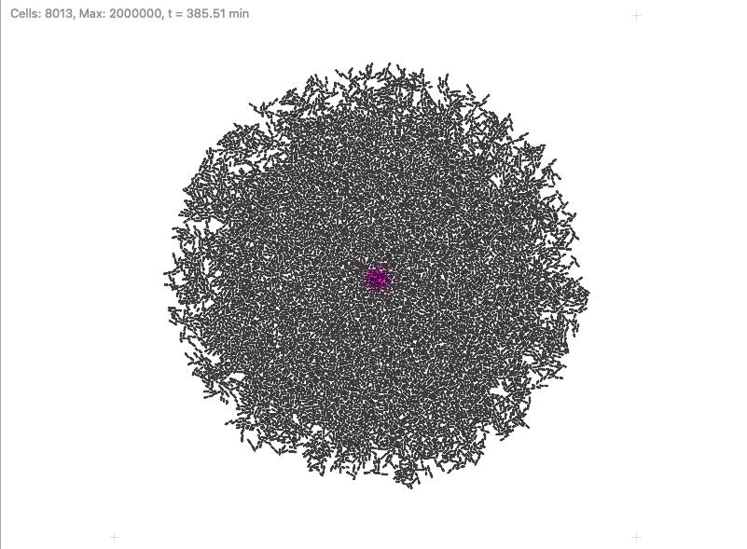

As you can see at a time of 385 the second potassium trigger has occurred in the centre of the biofilm

We then decided to measure the average concentration across the entire biofilm as a function of time. This was done by inputting the CVS file

To understand how the potassium wave velocity varies with curvature, we need to find the position of the potassium wavefront.

The first attempt is to use the point with highest value of concentration as the reference point.

We initially defined the wavefront: At a fixed time the wavefront is the radius at which the highest concentration occurs.

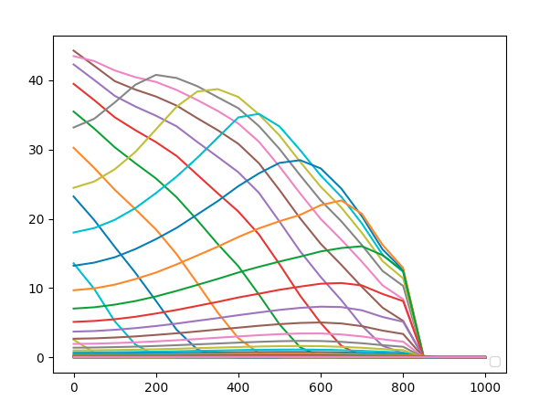

Average concentration versus radius at different fixed times.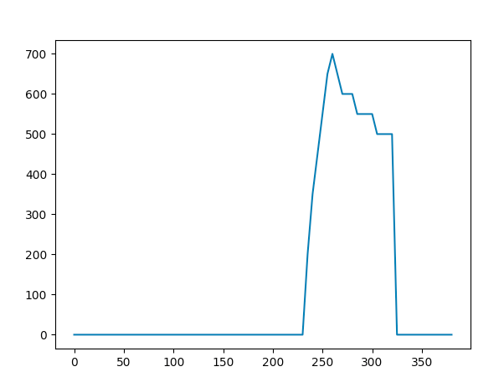

Position of peak versus time.

Average concentration versus time at different radii.We produced a graph showing the mean potassium concentration at fixed radius over time. A radius of 15(micrometres) refers to an average of all bacteria that are within 10 and 20 micrometres of the origin. This was repeated for multiple radii and the results were plotted as follows:

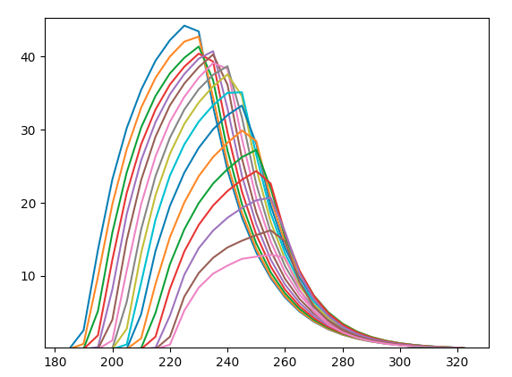

Average concentration versus time at different radii.

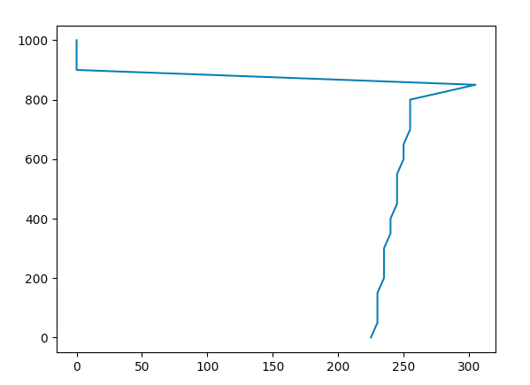

Position of peak versus time (obviously something’s wrong, a correction is needed).

All the graphs above are quite messy, we opted to make them smoother.

By narrowing the range of average and deleting the empty points, we obtained better graphs.

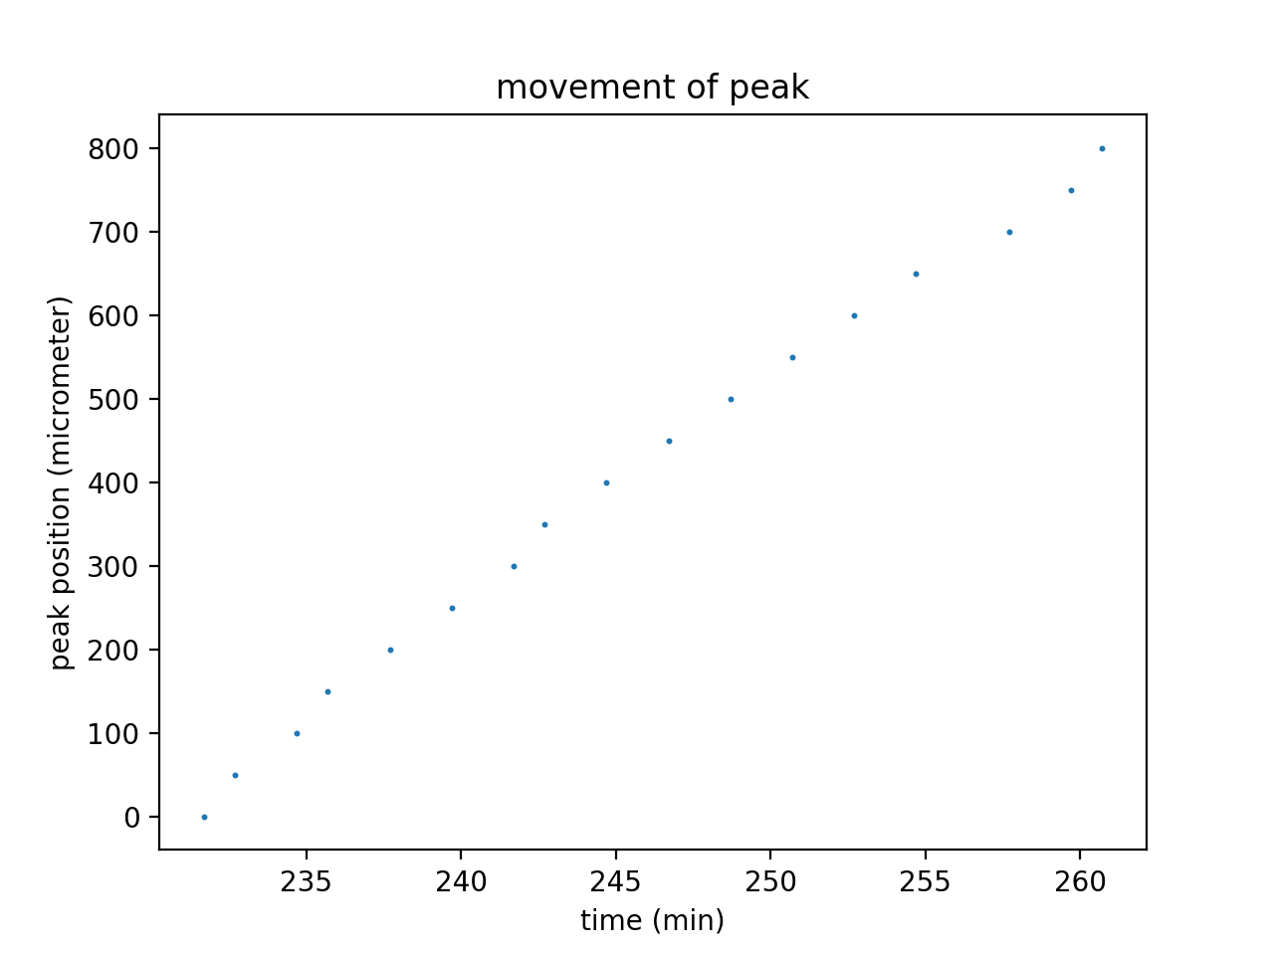

As we can see the peak moves quite linearly against time.

**15/04/2021**

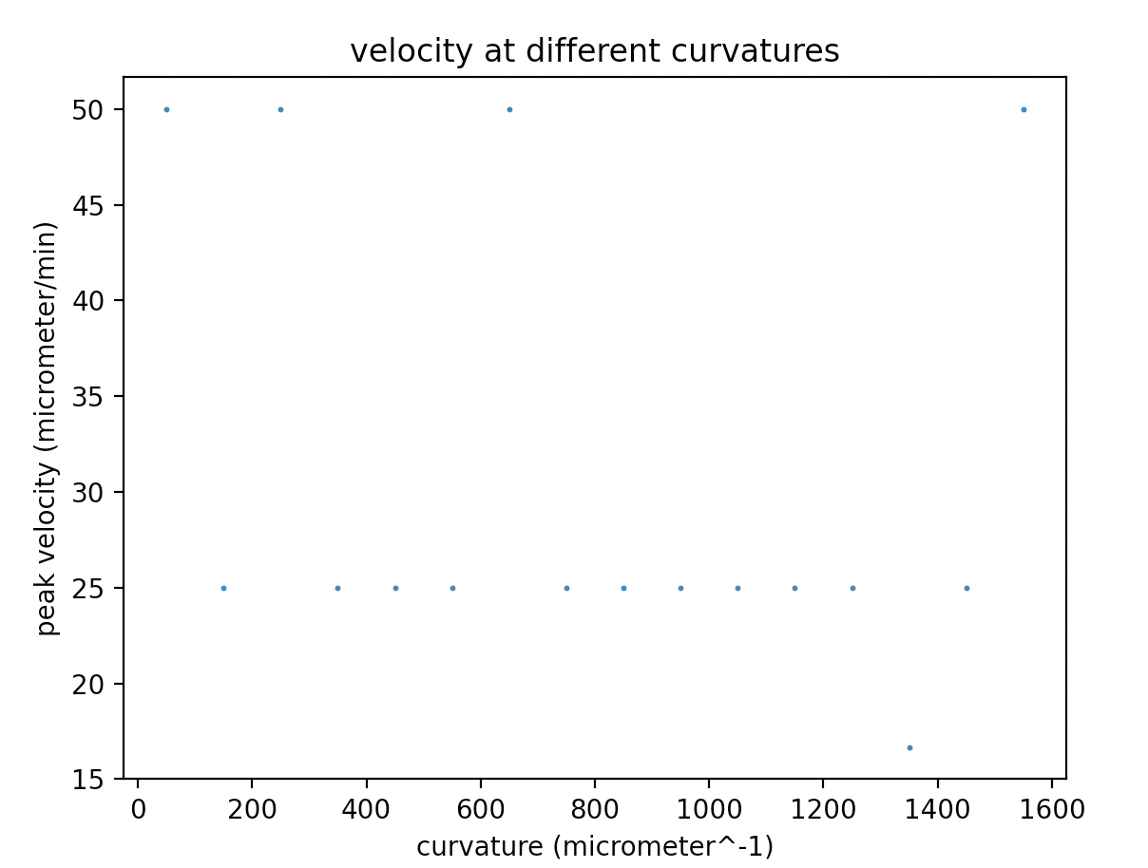

with the data mentioned above, we produced the graph showing change of velocity with respect to curvature, the result didn’t agree with the power law stated in the papers, so we decided to check our code.

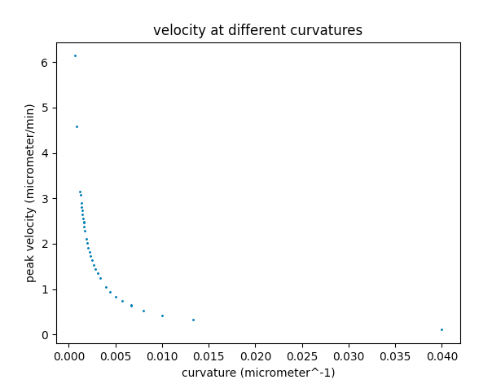

Well it turned out that the velocity mentioned in the power law curve was the average velocity. The previous graph was about differential velocity.

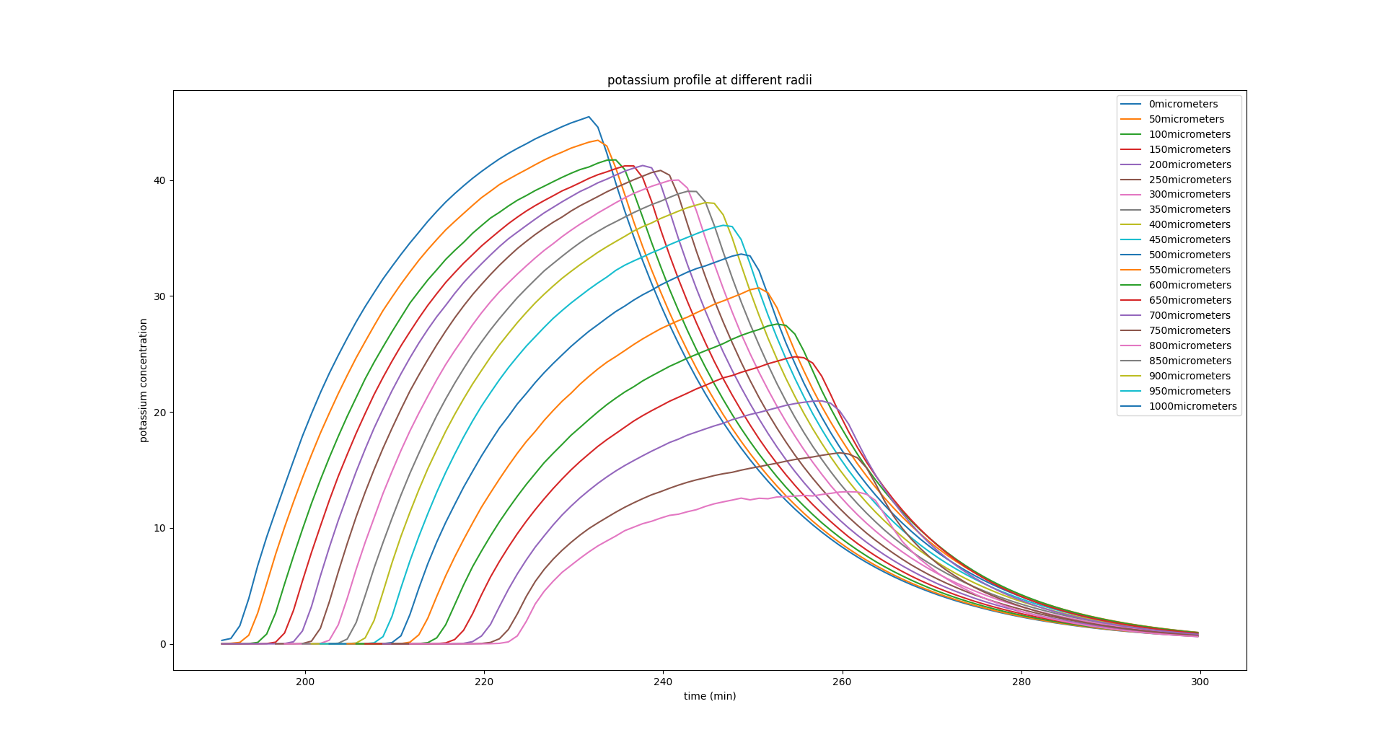

Height of the peak decreases during moving.

Meanwhile we tried to describe the spatial distribution of the bacterias in the colony.

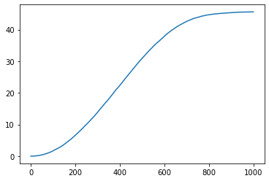

A very very rough estimate of the Ripley K function using the “RipleysKEstimator” function from astropy.stats. This is using all points across all time, should be completed again using snapshot of time, so we can see how the radial distribution varies.

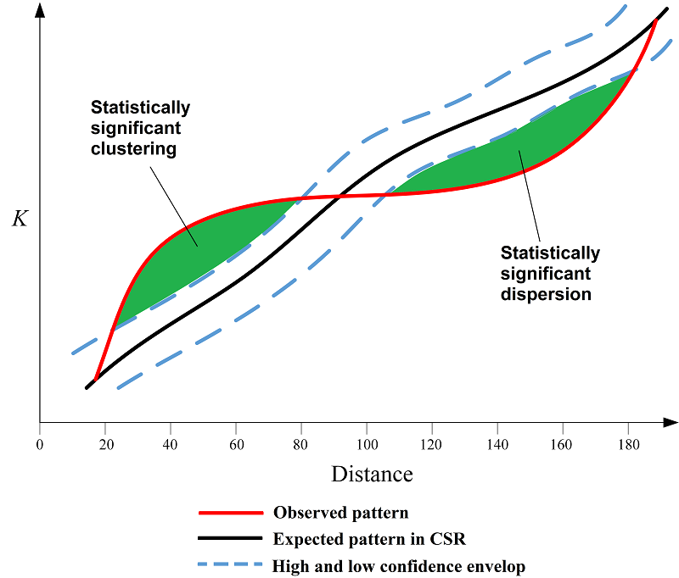

Possibly looks like dispersion at low radii and more clustering at high radii, but we need to check over time.

Below is an example run using profileAndPeak.py.

csv name=original_processed,dt=0.1min, dr=25micrometer: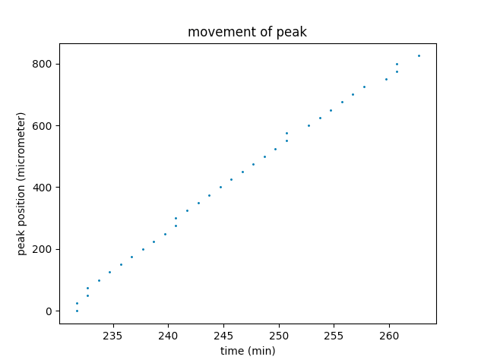

In our calculation average concentration at (r,t) refers to the average concentration of all the data points that fall in the region (r-r+dr, t-t+dt).

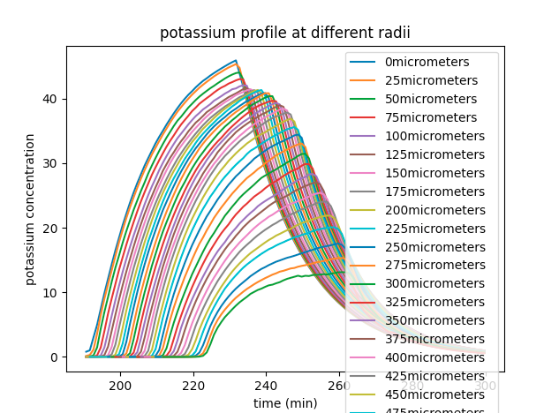

“Velocity” here is actually the peak’s average velocity since firing (assuming peak is at the origin when firing).

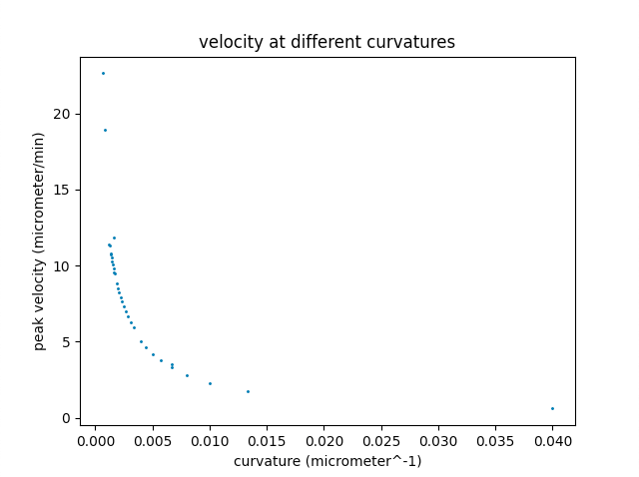

By this time the basic tool codes of analysing the movement of the wave have been constructed. Next we will start to get a better understanding of the theory.

We will start with the previous Mphys project paper.

Did not find much insight into the explanation of the differential velocity.

By using small time-step and radial-step(dt=0.05min,dr=0.05micrometer), we obtain the average position-time graph of the peak.

(position of the peak has been averaged for a given time grid point.)

The position curve was rather interesting, it seems to fit quite well to a neat function.

Next step would be trying this out.

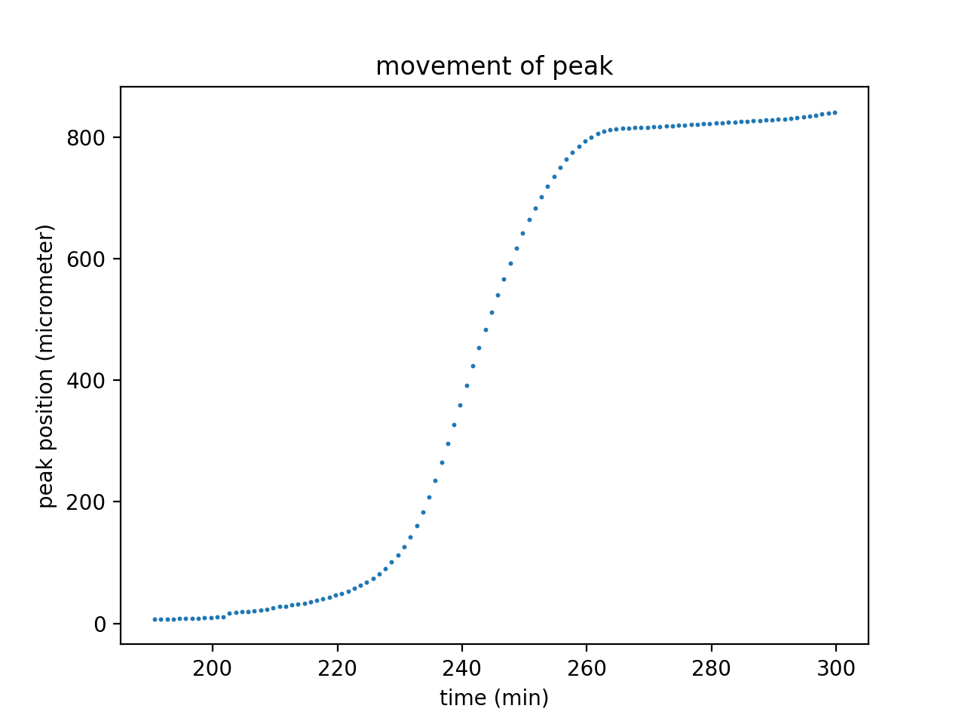

Differential velocity curve.

3 phase shape. Left and right similar to parts of different gaussians. What about the middle one?

Broken of symmetry may be the result of following factors:

1. Changes in cell density. (reference points at 200, 500)
2. Changes of curvature (including the corresponding difference in the phase of diffusion/cell-trigger/degradation——diffusion from a larger curvature to a smaller one; cell trigger is obviously a “one side” process and so is degradation)
3. Changes of “outside distribution” - spatial distribution of cells outside the radius

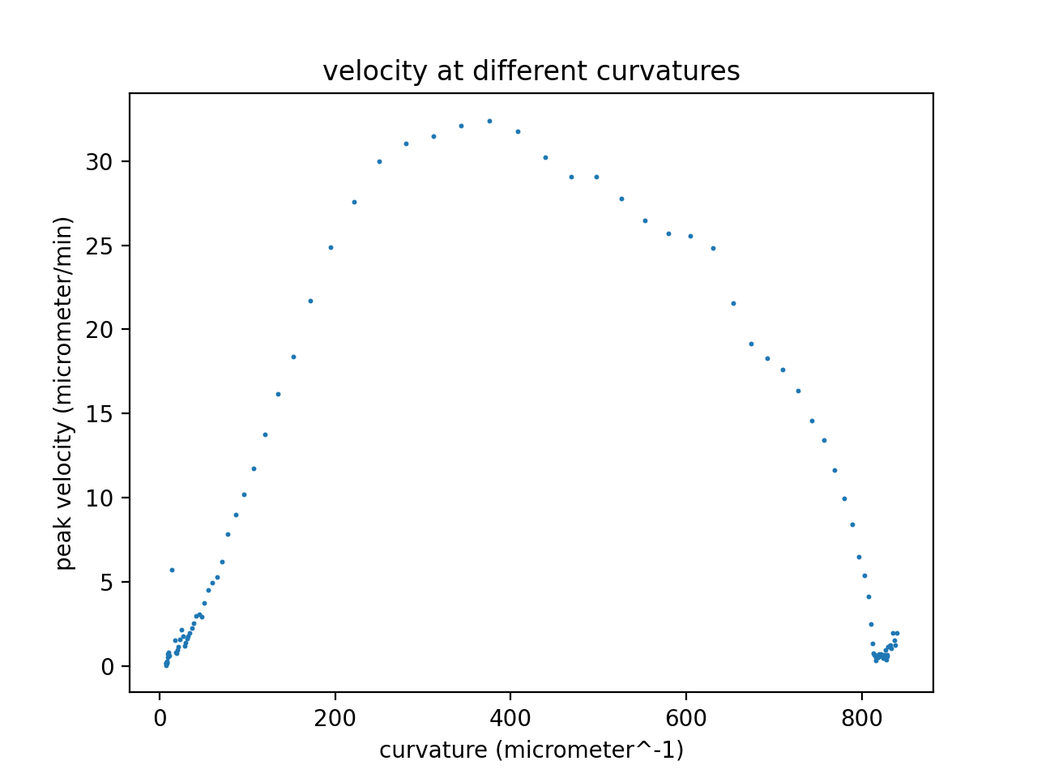*here the x-axis is radius rather than curvature

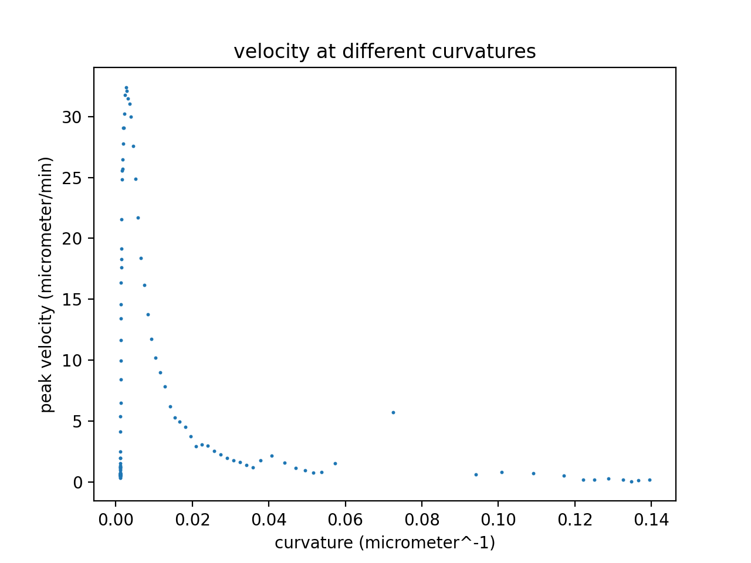Rather similar to the pair correlation function?

Before next week:

1. Read cardiac calcium ion paper.
2. Sort the current code.

Plan for next week:

1. Produce graphs on a more neat basis.
2. Fit the movement curve.
3. Test the similarity between velocity curve and pair correlation curve.
4. Fit concentration profiles to gaussians(2part-wise).
5. Try different parameters and see their influence on the movement of the peak.
6. Error analysis for contents obtained so far.

-How was the peak found?

With the potassium profile at a given radius we can find the peak point by simply picking the point with largest concentration.

Taking the time of the point and radius of the considered profile, we obtain a space-time position of the peak, which, if we take the peak as the reference point, is a data point of the whole space-time trajectory of the potassium wave.

-How did we get average velocity?

We have multiple radii. Each radius has a peak concentration at a given time.

First we calculate the average position of the wave at each time point of the grid.

Assuming constant velocity between neighboring time points, the velocity is regarded as the change in average position over time period, the corresponding radius is regarded as the midpoint during the small movement.

**20/04/2021**

When the wave reaches 800 micrometer (and maybe a little period before that), the wave has reached the area where there are no cells and subsequently the simulation breaks down. Therefore that part of the data should be removed.

(We decided to use curve_fit() from scipy.optimize to fit the curves.)

After that we tried to fit the movement curve to a power law, yet the result wasn’t satisfying.

(Power law used here is $r=at^{b}+c$.)

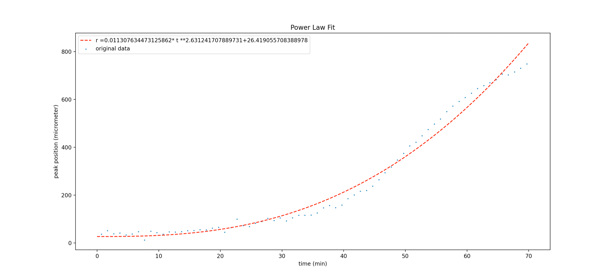

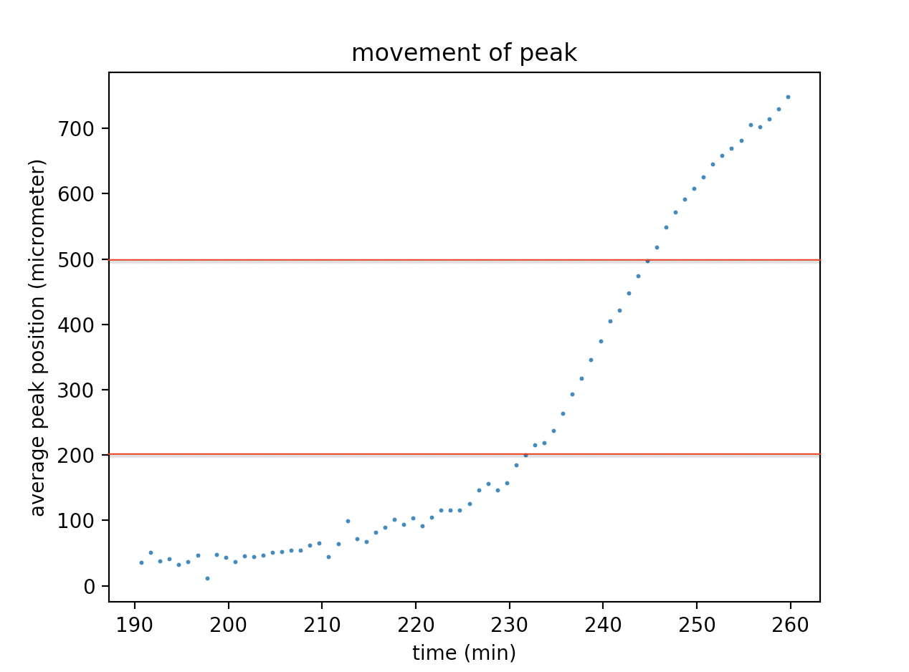

Our speculation is that due to the different cell density in different radius areas(0-200, 200-500, 500-80), the movement would experience 3 different phases, so we will attempt to fit them separately to different power laws.

To test the speculation mentioned above, we ran a “homogenous” case, in which everything stayed the same except for now the cell density should be (on average) constant.

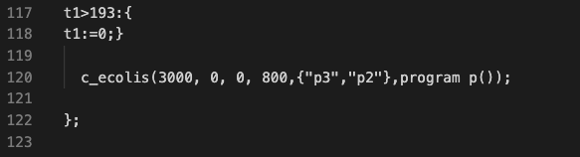

Peak position curve fitted to a power law.(Power law used here is $r=at^{b}+c$.)

More comparisons can be introduced here.

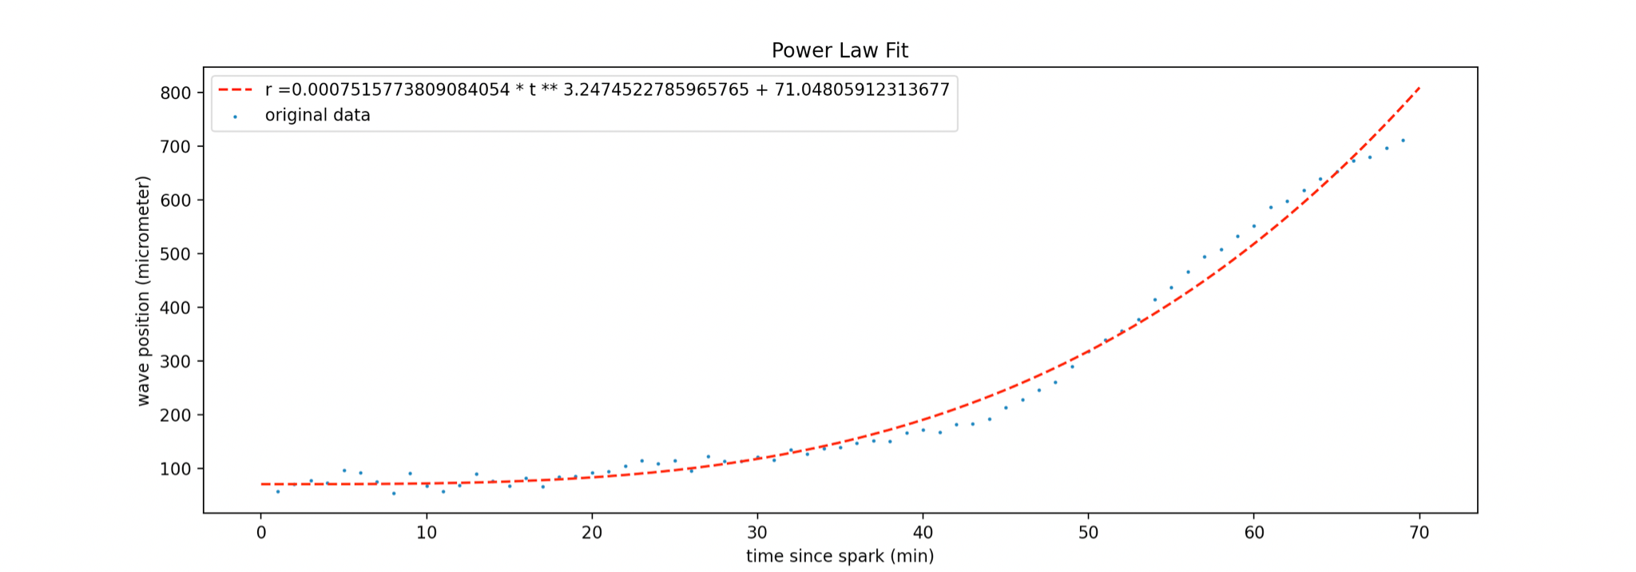

(3000 cells, size 800)

As we can see the movement of the peak still has the “three phase” character mentioned before, so the influence of cell density may not be that important?

Therefore a new speculation was come up:

Why the three phase character?

Lag - The cross-membrane transportation of potassium ions takes a noticeable amount of time to happen, which suggests the activation and release of potassium as well as the accumulation of the peak concentration don’t happen immediately, therefore in the fire-diffuse-fire model:

i) the position of potassium peak is actually behind that of the most recently activated cell

ii) the peak’s formation is also affected by the “forward” cells’ potassium release.

And with above statements we explain the three-phase character as below:

1.The starting phase - first set of cells were arbitrarily activated, due to the lack of “backward” cells and the potassium accumulation (over all maybe?), the wave moves slowly.

2.The stable phase - the system reaches a balance of potassium accumulation, backward cells and forward cells, peak position moves at a constant velocity.

3.The decaying phase - as the peak approaches the edge of the colony, due to the lack of forward cell and loss of potassium (diffused out of the colony), the balance is broken and the velocity decreases.

We will run simulations of homogeneous colonies of different sizes to test this speculation.

(3600cell, size1000)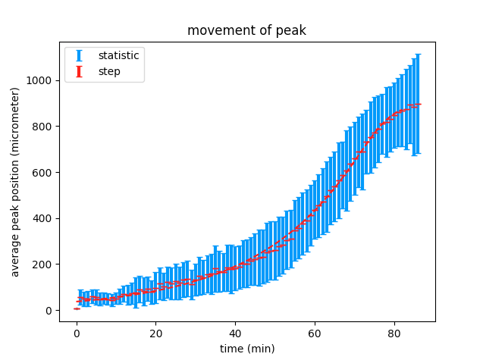

(3000cell, size900)

(2500cell, size600)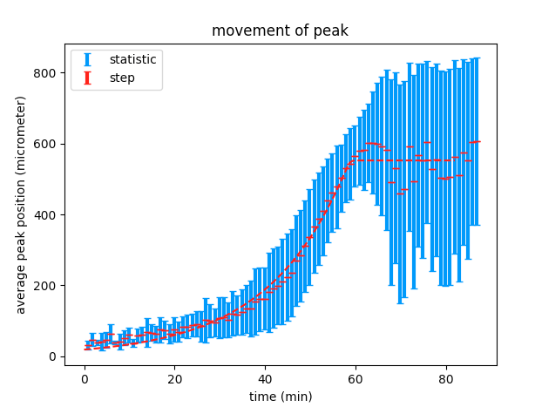

All cases show 3-phase character, which supports previous speculation.

The phase of interest is the second one, we are interested in the relation between the velocity and the diffusion and degradation of potassium.

Setting dr to be relatively large would directly give us a good description of the second period.

flag

Now back to the original case.

Meanwhile, we shall:

1.fit potassium profiles to gaussians and determine the errors(?)

2.fit the average velocity versus curvature curve and determine the errors (systematic: randomness;discreteness; Statistic?)

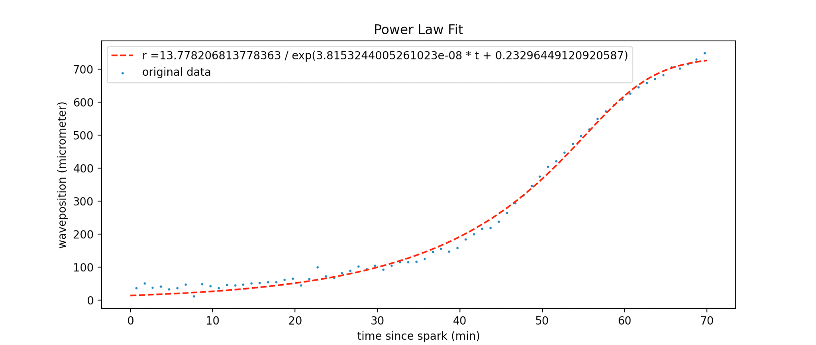

Fitted to modified sigmoid function(dt=0.05min,dr=0.05micrometer).

(Sigmoid function used here is $r=\frac{a}{e^{bt}+c}$.)

Average velocity - curvature fits quite well to a power law(dt=0.1min, dr=25micrometer).

(Power law used here is $v=lc^{m}+n$.)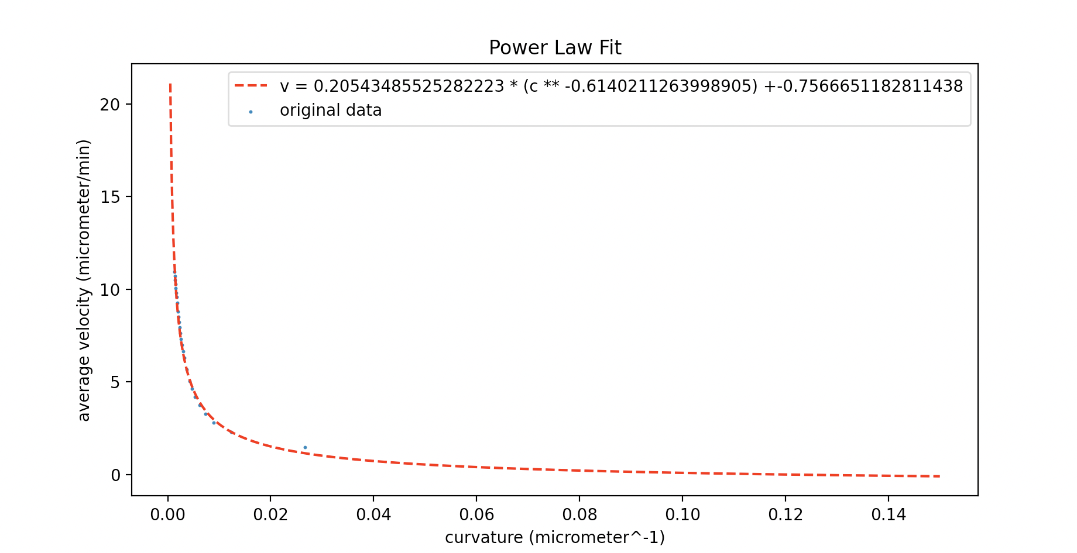

Next we will look into the errors involved.

**22/04/2021**

In our calculation average concentration at (r,t) refers to the average concentration of all the data points that fall in the region (r-dr/2-r+dr/2, t-dr/2-t+dt/2), so we shall take the standard deviation concerning discretization error to be dr/2 and dt/2.

The standard statistical error on the mean is $σ/\sqrt{N}$.

(σ is the standard deviation on the mean peak position and N is the number of the data points that fall in the region (r-dr/2-r+dr/2, t-dr/2-t+dt/2))

More information needed

As we can see, for average positions the statistical uncertainty dominates.(dr=1,dt=0.1)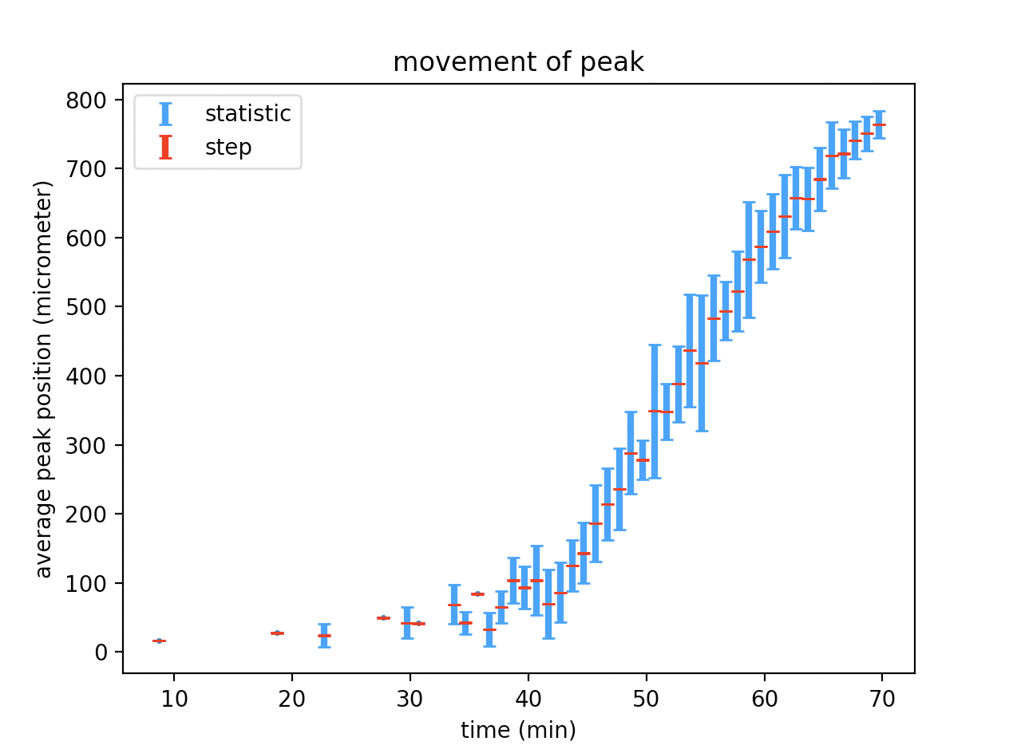

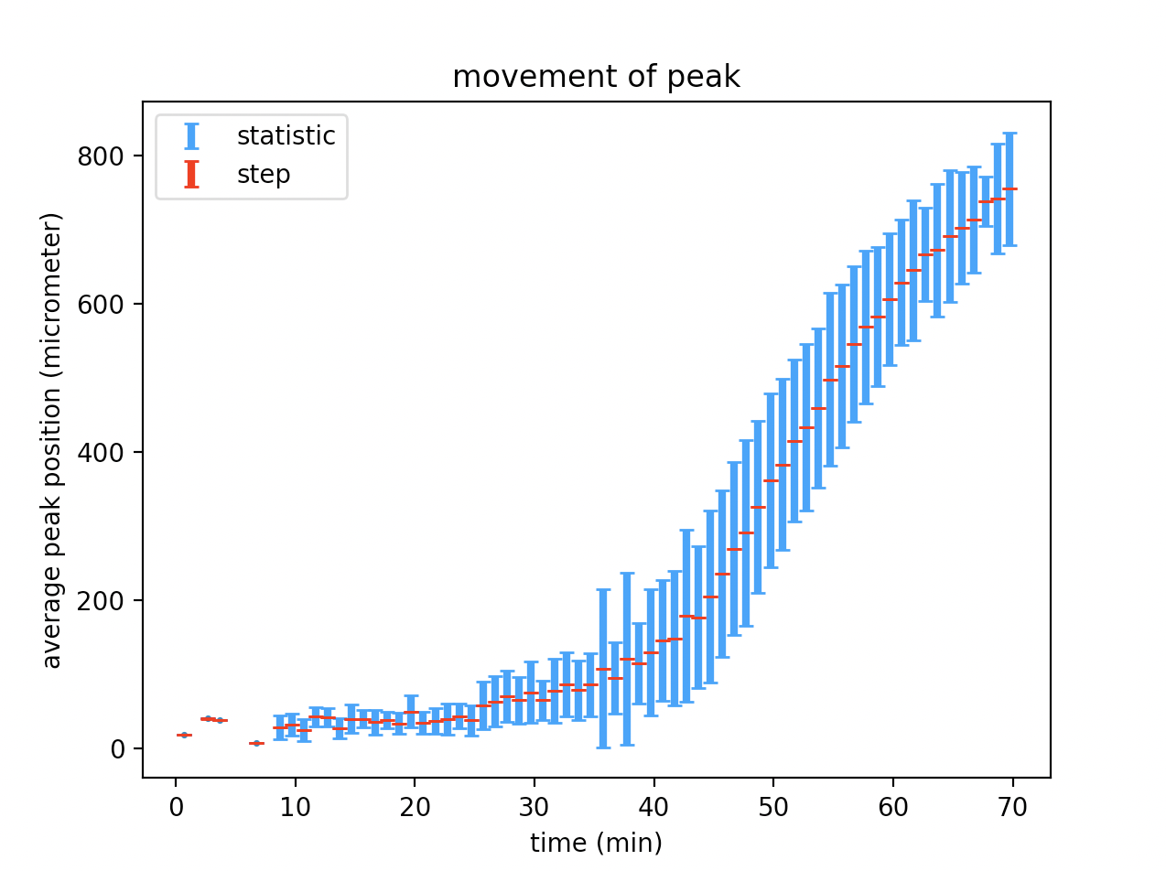(another run, dt=0.05, dr=0.05)

Average velocity is $v=\frac{r}{t}$, taking dr and dt as error for r and t, $dv=\sqrt{(\frac{dr}{t})^{2}+({\frac{rdt}{t^{2}})}^{2}}$.

Knowing the statistical factor dominates the uncertainty of average positions, in the expression above we regard dr as the statistical uncertainty obtained previously, and take half-step dt/2 as uncertainty dt, therefore we can get the “mixed error” for average velocity.

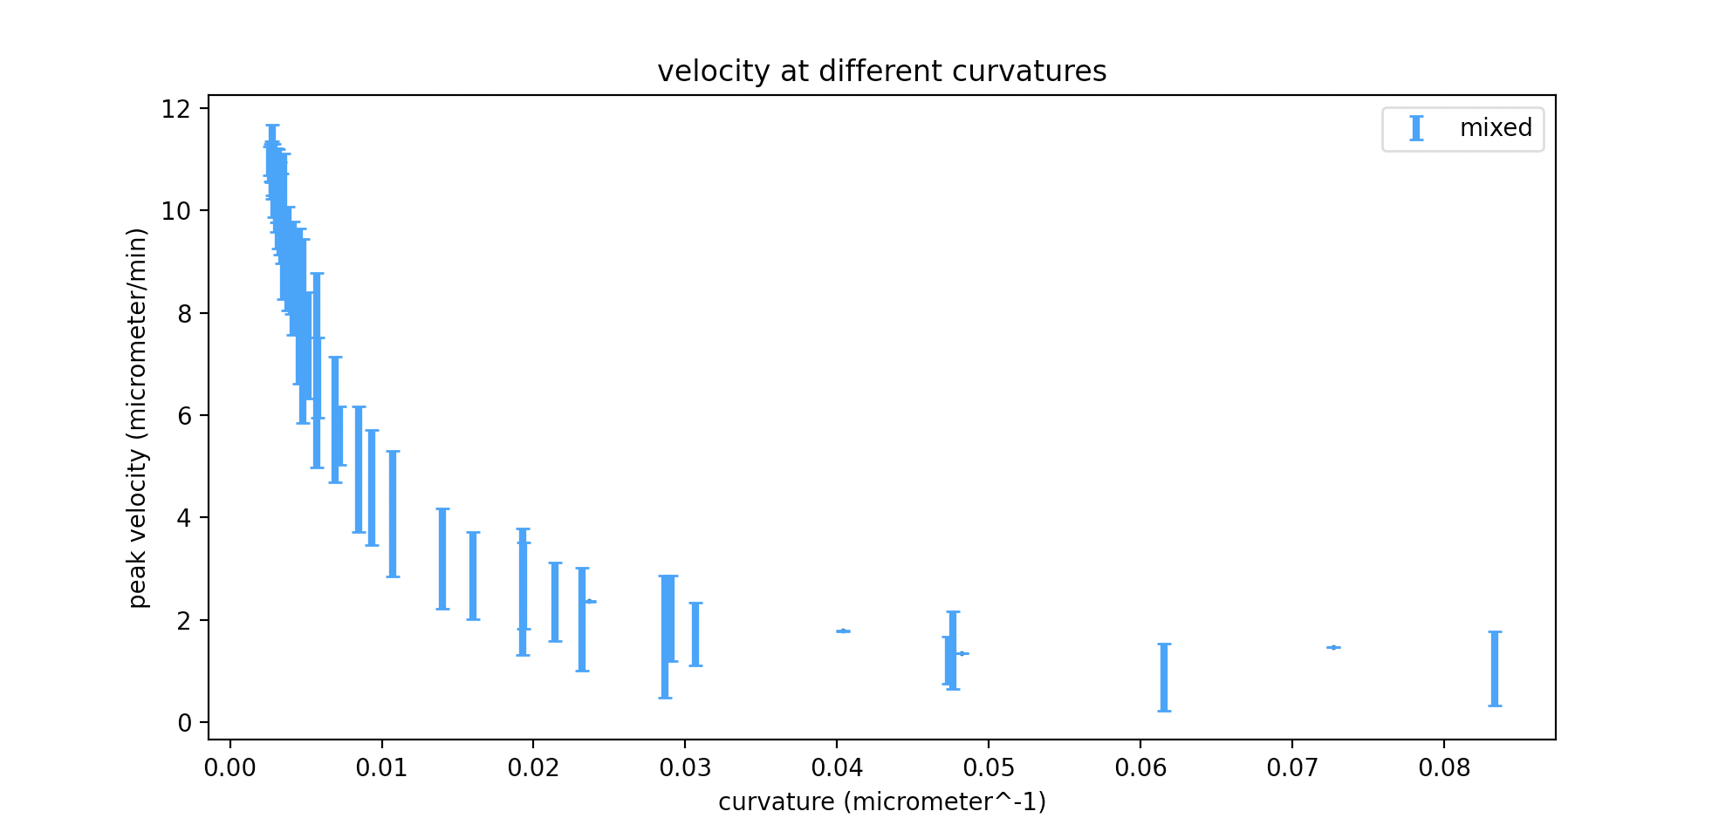(dr=1,dt=0.1)

Further examples showed that at small dr, statistical uncertainty dominates, at large dr, step uncertainty dominates.

Therefore we’ll treat the two as independent uncertainties, therefore:

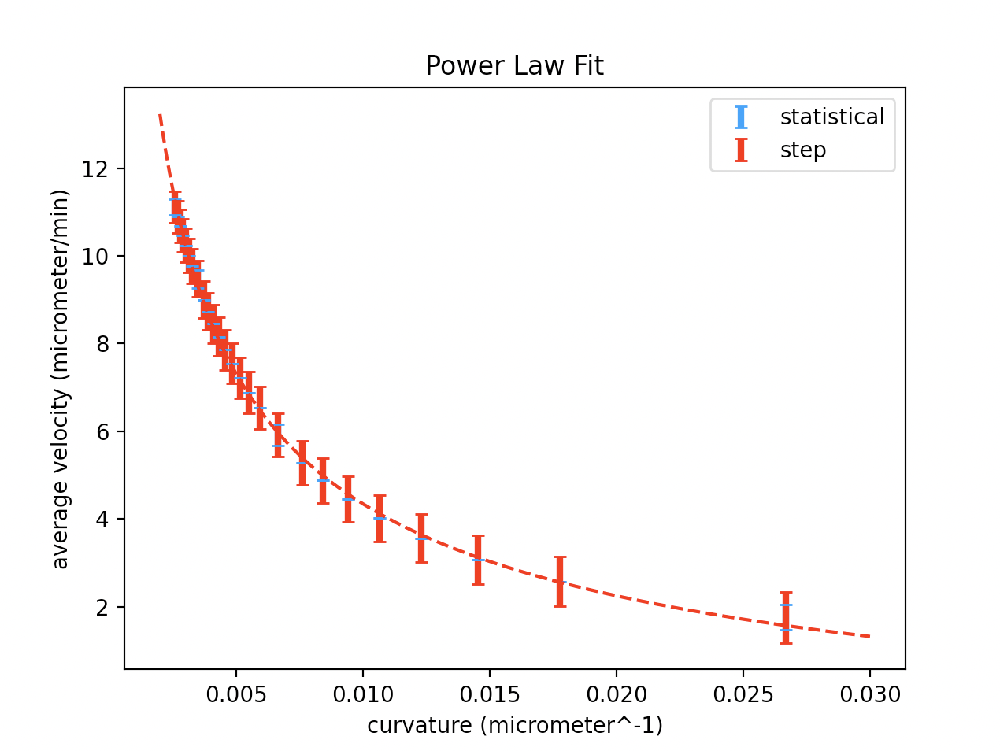(dr=25,dt=0.1)

Also stochastic error should be considered. We plan to run multiple simulations and take the max difference as the stochastic error.

flag

Spatial analysis

Using astropy libraries, specifically astropy.stats import RipleysKEstimator a python program to import the spatial coordinates of the biofilm at a selected time and output a graph of ripley K value against radial distance from origin was produced. The graph below was produced:

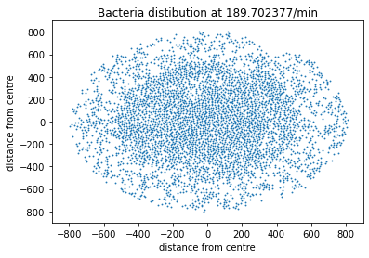

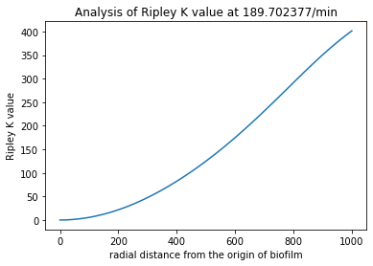

In order to analyse how this spatial distribution changes over time as the biofilm grows a simulation was ran from 0mins to 300mins and graphs were produced at intervals of ……..minutes. As a check of how this RipleyK value relates to the distribution a numer of sample datasets were produced. Mainly the np.random function was utilised to produce a set of x and y coordinates randomly distrubuted over the same area of study utilised for the biofilm distribution.

In order to produce a randomly distributed circular distribution the following methodology was used:

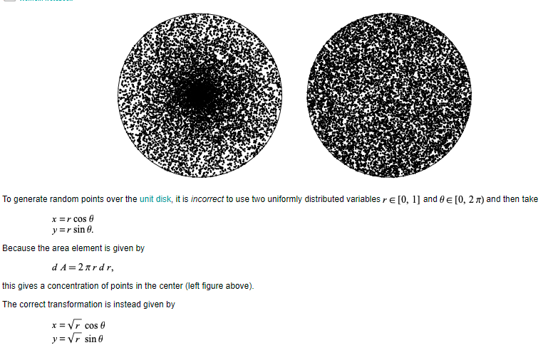

Note the radius and number of datapoints selected here match the average maximum radius and no of data points in the simulated datasets.

The code reads the simulated data coordinates at a selected snapshot in time. It then makes a random uniform distribution of the same number of coordinates within the same maximum radius. It plots both of these distribution and then calculates the ripley K value as a function of radial distance from each point. The search area is automatically set to the area of the biofilm and the radius of search is set to the max radius of the distribution. By setting it this way the ripley K values can be calculated and compared with a random distribution of the same sample size and radius for any time in the simulation.

In order to analyse the spatial distribution as the biofilm grows we will run a simulation starting from one bacterium and then growing outwards, and see how the spatial relation, measured by the RipleyK varies as the biofilm is produced.

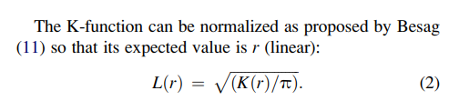

From:

Biophysical Journal Volume 97 August 2009 1095–1103

On the Use of Ripley’s K-Function and Its Derivatives to Analyze Domain Size

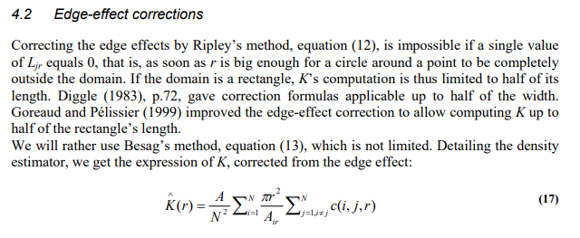Eric Marcon, Florence Puech. Generalizing Ripley’s K function to inhomogeneous populations. 2009. Ffhalshs-00372631f

Although Astropys estimation function includes edge effects, it is clear based on Diggle and Goreaud and Pelissier that to produce meaningful results the radius used should be around ½ of the maximum radius of the distribution.

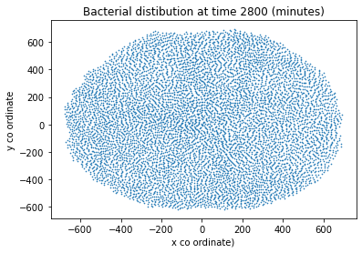

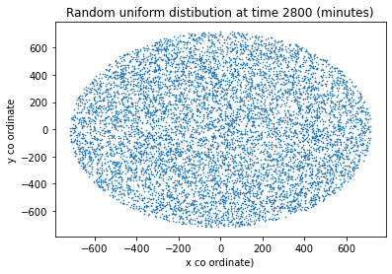

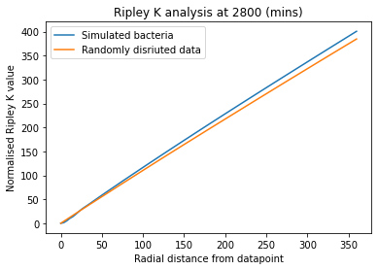

As anticipated we see a linear relation for the randomly distributed data. The simulated biofilm has a normalised ripley K value that is greater than the random, the literature says that this implies greater clustering in the spatial arrangement. Interestingly at very small radii it appears that the ripley K may be smaller in the simulated data than against the null hypothesis.

The x axis will be rescaled to view these effects at small radii from a given datapoint.

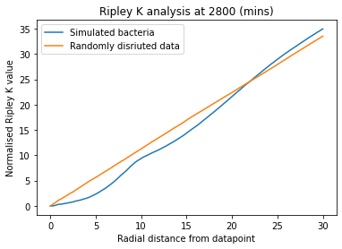

It is clear that below radial distances of about 22.5 the simulated data is more dispersed than the null hypothesis. This is likely due to the geometric limitations imposed by the dimensions of the bacteria. (eg- they cannot overlap and they have some size).

At earlier times this plot is useless

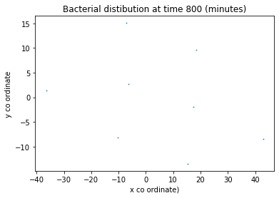

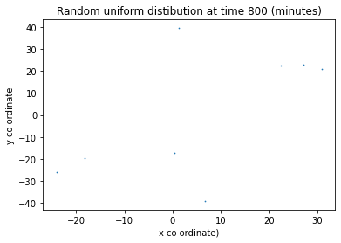

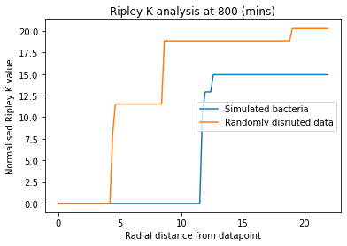

However, at slightly later times the pattern begins to appear

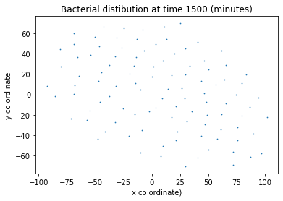

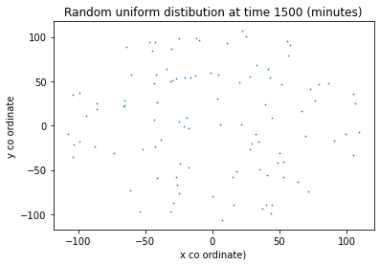

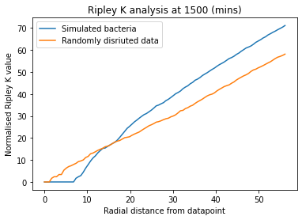

And finally once the biofilm is fully formed we get the graphs at 2900 minutes

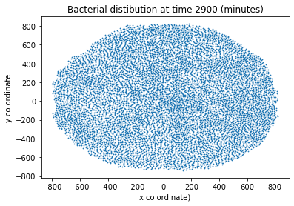

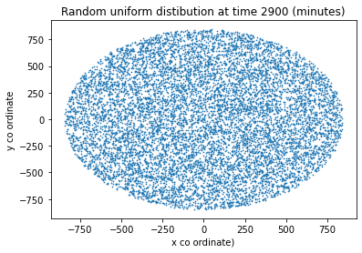

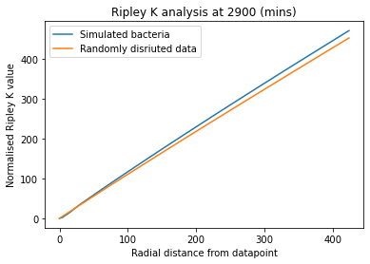

Another method to analyse the spatial distribution of the bacteria is the pair correlation function. In [statistical mechanics](https://en.wikipedia.org/wiki/Statistical_mechanics), the **radial distribution function**, (or **pair correlation function**) in a system of [particles](https://en.wikipedia.org/wiki/Particles) (atoms, molecules, colloids, etc.), describes how density varies as a function of distance from a reference particle.

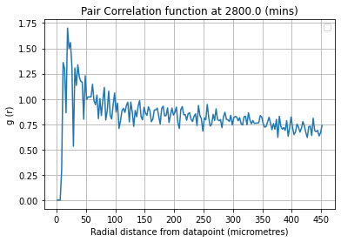

This can once again be paired with the null hypothesis

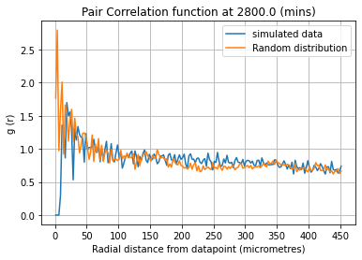

Density VS Radius

In order to analyse the density as a function of radius we create a program that at a given time records the no of cells per unit fixed area. This is done using the relation ship that if we take an initial central circle dr. Then for subsequent radial rings we have boundaries given by:

${r_{n}=\sqrt{n*{dr}^{2}}}_{}$

This ensures the area of every measurement is identical.

Hence the density is n/area where n is the no_bacteria inside a radial band and A is the area pi*r^2.

This produces an uncertainty on the radius

${σ_{r}=\frac{r_{n}-r_{n-1}}{2}}_{}$

This is used as an errorbar on the plots below. We plot for our current situation with 3 phases of density, and also the case where we use a homogenous distribution.

Using original.csv with dr=150

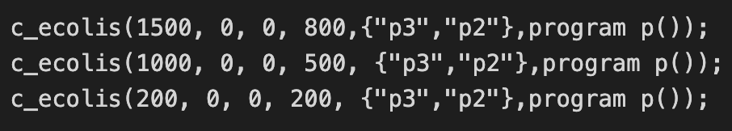

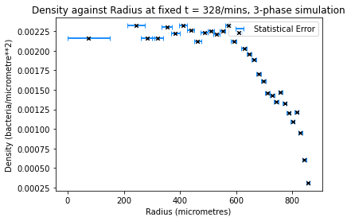

We can see these three phases most clearly in the slower drop of the density between 500 and 800 where with the homogenous case we see a more constant density with a sharp drop at the outer radii.

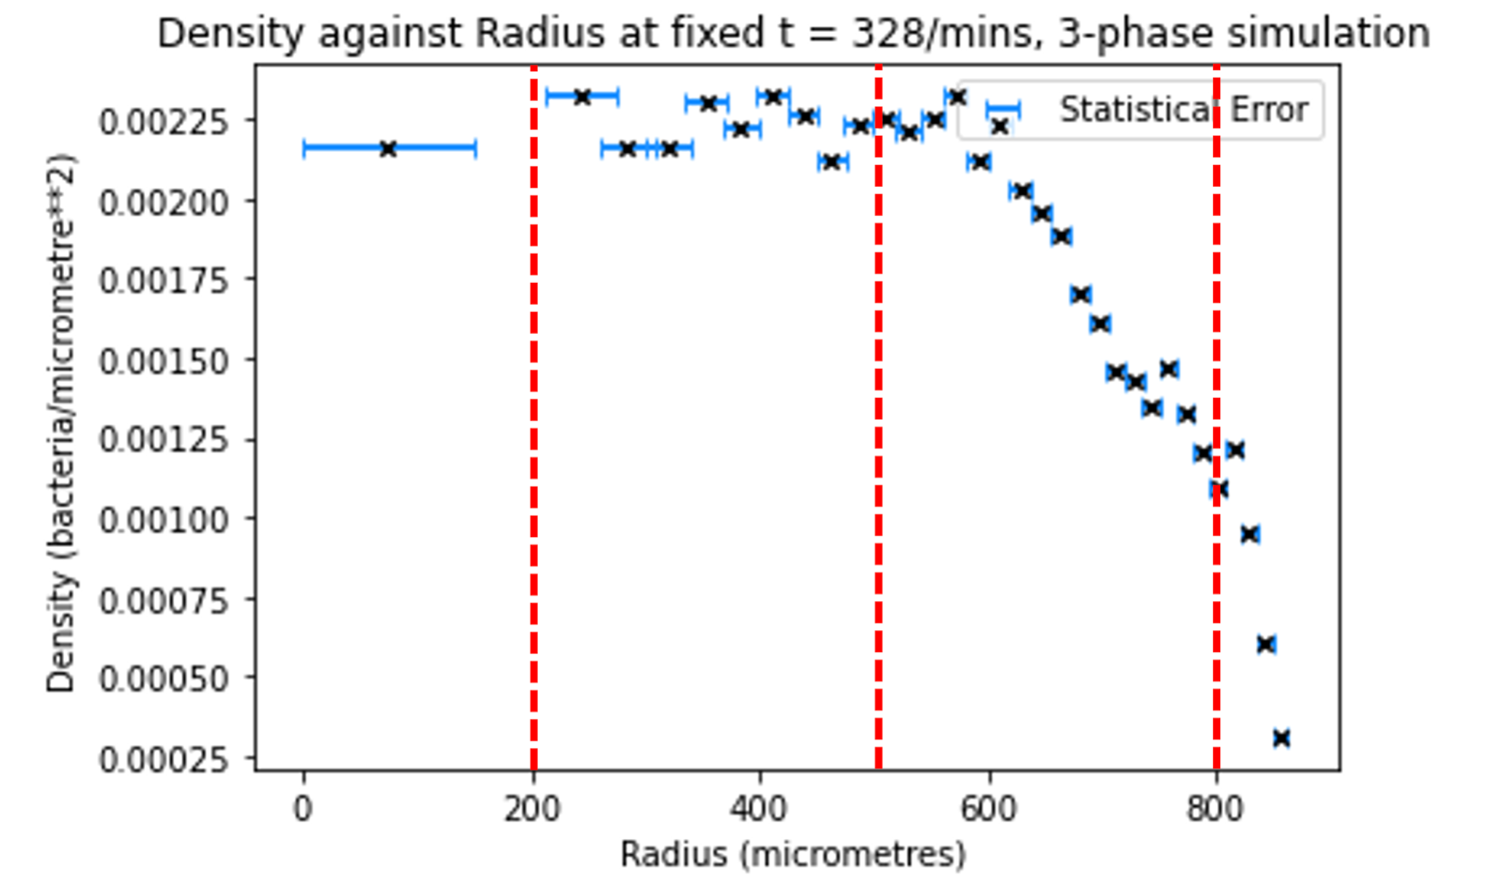

Using Homogenous.csv with dr=220

